Use this template to invite your collectors (via email or social media) to attend the June 2021 Rittenhouse Square Art Show – Virtual Edition. Fill in the information that corresponds to the event(s) you are participating in during the weekend of the show.
It’s best for you to promote the show with all of your collectors, not just the Philadelphia region, because anyone with an internet connection can easily attend the show.
The June 2021 Rittenhouse Square Fine Art Show will be VIRTUAL!
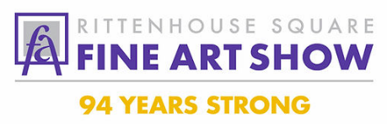
June 4, 5 and 6 – Friday, Saturday and Sunday
The June show is everywhere and anywhere you have an an internet connection!
I hope that you’ll visit me during the weekend of the show at my Virtual Booth.
(if you have a virtual booth use the information below)
My Virtual Booth:
You will be able to visit my Virtual Booth via Zoom during My Visiting Hours (listed below). At that time, you’ll be able to view my artwork, talk with me one-on-one, ask me about my process, and even show me your space where you would like to place a piece of art.
To visit my Virtual Booth, just click on the Zoom link below during my visiting hours.
My Visiting Hours are: (insert your visiting hours)
Here is the Zoom Link to visit my Virtual Booth: (insert your booth link)
If these visiting hours are not convenient for you, please email me: (insert your email address) to arrange a more convenient time during the weekend of June 4-6.
If this is your first time using Zoom, click on the Virtual Booth link during my visiting hours and follow the instructions to download the Zoom app.
(If you are doing a Demo in Facebook Live or having an Instagram Interview add the information here).
In addition, you can access more information about all the events taking place during the show weekend through the RSFAS website: https://www.rittenhousesquareart.com.
- Art Demonstrations in Facebook Live
- Artist Instagram Interviews
- Virtual Booths
- On-line Shopping Gallery

